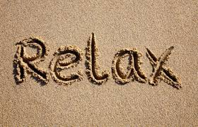
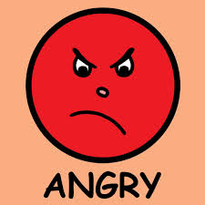
PowerPoint: "Ten Relaxation Techniques to Zaps Stress Fast" | Article: "How to Handle Anger Well"
How do meditation and deep breathing help to reduce stress? | What are some of the results of poor anger management?
Why is it important to reach out to others? | List at least three signs that anger is not being managed:  1.  2.  3.
Why does laughing reduce stress? | What are the steps to managing your anger?
Which of these techniques do you think would work best for you? | What is a trigger for your anger? How can you control it?

1. Describe a time when you became very angry. What was the situation? How did you resolve it?

2. What is an alternative to the strategy you used to resolve the situation?

3. Why is it important to think about the consequences of reacting angrily?

